Foreign Travel Support approval through GT-TRACS
Step 1: for your traveler, select an “Other” package type and click “Create New Package”.
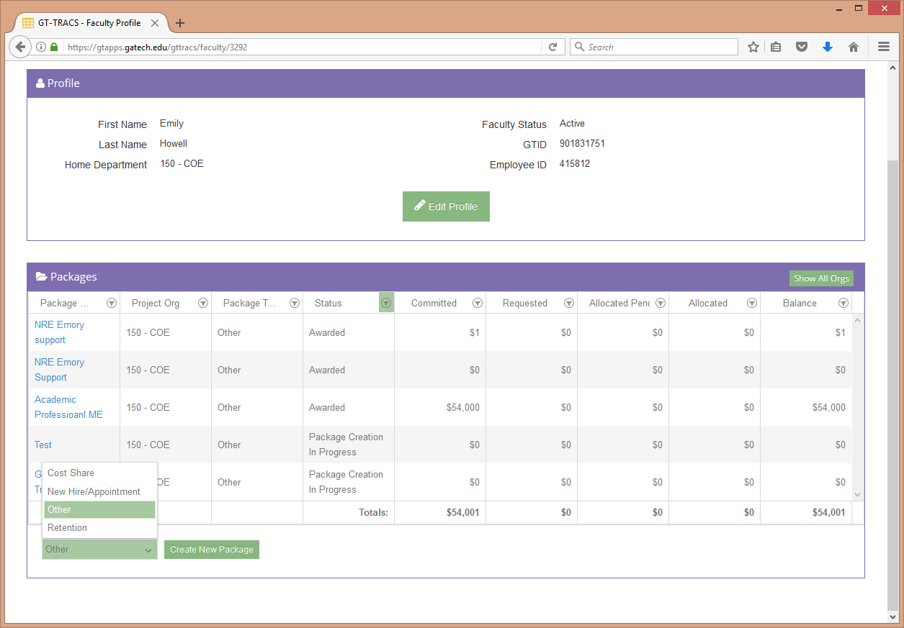
Step 2: On the package info tab, select “Foreign Travel Support” from the Other Type drop down list. If this option is not selected, the package will be returned. For package name, please use “FYXX Travel Support” using the fiscal year that travel will occur.
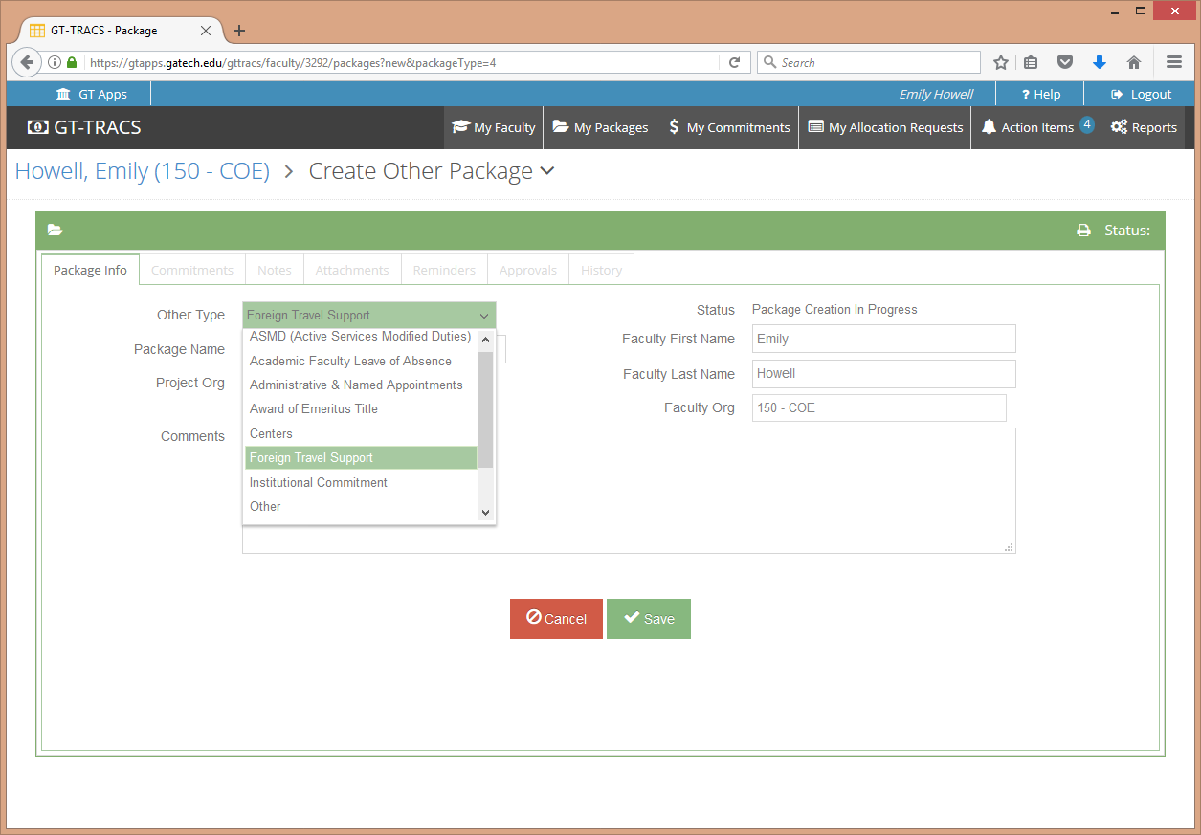

Step 3: Complete the commitments tab for the amount requested. The maximum amount requested is $1500. Requests over $1500 will be returned. You do not have to request these funds. This is for COE internal tracking only.
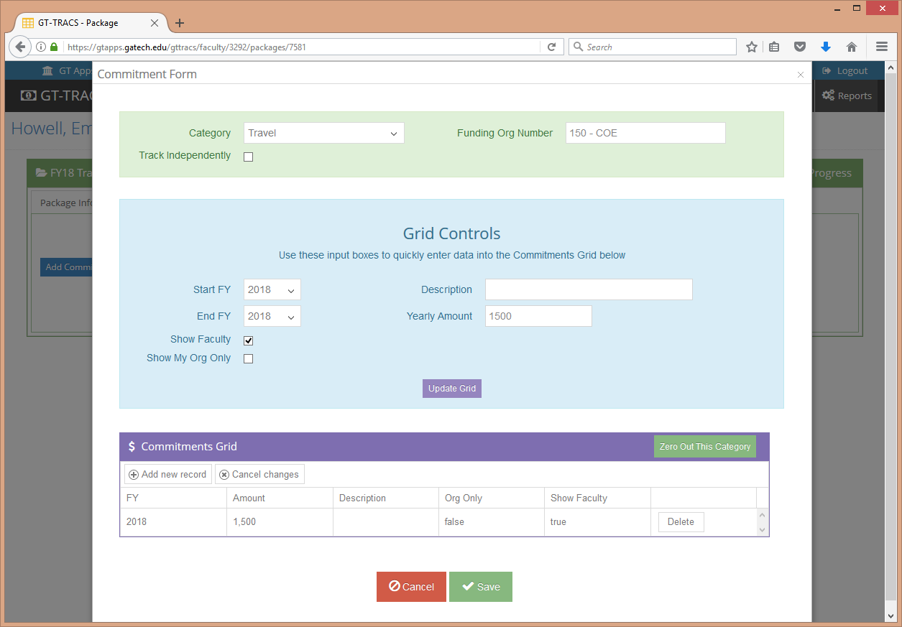

Step 4: When approved, the school should forward the approval notification to the traveler. School should include the COE worktag to charge (DE00001615) in the email.

